Project Design Phase-II
Data Flow Diagram & User Stories

Date | 24 November 2025
Team ID
Project Name | Flight Booking App
Maximum Marks | 4 Marks

Data Flow Diagrams:
A Data Flow Diagram (DFD) illustrates how data moves within the Flight Booking App, showing how travelers and flight operators interact with the system, how information flows between components, and where flight, booking, and payment data are stored.”
DFD Level 0 (Industry Standard)

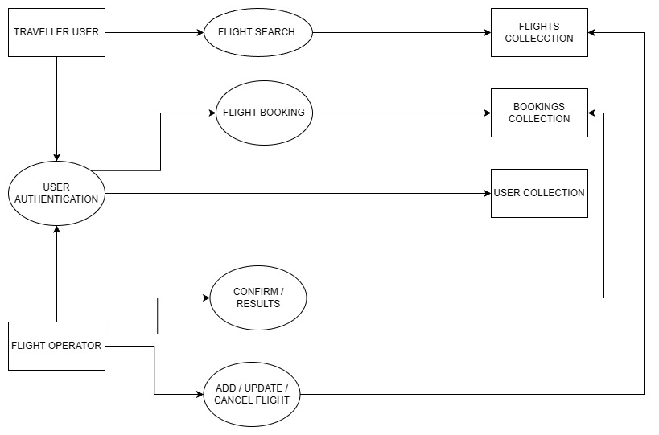
User Stories

User Story Table – Freelance Finder
User Type | Functional Requirement (Epic) | User Story / Task | Acceptance Criteria | Priority | Release
Traveler | User Authentication | As a traveler, I can create an account and log in securely. | User is able to sign up, log in, and access their dashboard. | High | Sprint-1
Traveler | Flight Search | As a traveler, I can search for flights using origin, destination, and date filters. | Search results show available flights matching the criteria. | High | Sprint-1
Traveler | Flight Booking | As a traveler, I can book a flight and receive a confirmation ticket. | Booking appears in "My Bookings" with ticket details. | High | Sprint-2
Traveler | Seat Selection | As a traveler, I can select seats during booking. | Selected seat is reserved and reflected in booking details. | Medium | Sprint-3
Traveler | Payment Processing | As a traveler, I can make secure payments for flight bookings. | Payment succeeds and is displayed in transaction history. | High | Sprint-2
Traveler | Booking Management | As a traveler, I can view, cancel, or modify my bookings. | Updated booking status is shown immediately. | Medium | Sprint-3
Traveler | Notifications | As a traveler, I receive email/SMS alerts for bookings, cancellations, or delays. | Notifications are delivered in real-time. | Medium | Sprint-3
Flight Operator | Flight Management | As a flight operator, I can add new flights to the system. | Flight appears in admin panel and search results. | High | Sprint-1
Flight Operator | Update Flight Details | As a flight operator, I can modify timing, price, and seat availability. | Updated details appear instantly in search results. | High | Sprint-2
Flight Operator | Cancel Flights | As a flight operator, I can cancel or disable flights temporarily. | Flight marked as “Cancelled” and no longer bookable. | Medium | Sprint-3
Admin | User Management | As an admin, I can manage users (travelers/operators). | CRUD operations work and reflect correctly. | High | Sprint-1
Admin | System Monitoring | As an admin, I can view logs and monitor app activity. | Logs update in real-time. | Medium | Sprint-3
User (Traveler/Operator) | Messaging / Support | As a user, I can raise support tickets and receive responses. | Ticket status updates correctly and responses are visible. | Low | Sprint-4

